Computational Framework for Streptococcus mutans Biofilm Analysis Under SEM and Confocal Microscopy Imaging

- Introduction
Bacterial biofilms are complex, structured communities of microorganisms encased in a self-produced extracellular polymeric matrix composed of polysaccharides, proteins, extracellular DNA, and lipids. This matrix confers mechanical stability, facilitates intercellular communication through quorum sensing, and provides a physical barrier against antimicrobial agents and host immune defenses. As a result, biofilm-associated bacteria demonstrate substantially greater resistance to antibiotics, with minimum biofilm inhibitory/eradication concentration values significantly higher than their planktonic counterparts (1). This presents major challenges in treatment of diseases caused by biofilm formation, which are estimated to account for up to 80% of chronic microbial infections, including such conditions as urinary tract infections, cystic fibrosis and rhinosinusitis (1–3). One prominent example of a biofilm-forming, clinically relevant bacterium is that of Streptococcus mutans (S. mutans), the principal etiological agent of dental caries. S. mutans forms biofilms on tooth enamel and other dental surfaces (e.g., gingiva, dentures), leading to persistent infection in the oral cavity, which can lead to structural tissue degradation (4). The clinical and societal burden of biofilm-related diseases is a strong motivator for ongoing efforts to characterize biofilm structure, accurately quantify its treatment effects, and develop reproducible analytical frameworks for biofilm assessment.
Traditional biochemical methods commonly used to characterize biofilm development include viable cell enumeration (e.g., CFU, FACS), proxy markers for biofilm biomass (e.g., crystal violet staining), metabolic activity assessment (e.g., MTT) and ATP bioluminescence which measures the metabolic energy. (5). While these methods provide quantitative metrics of biofilm mass and viability, all are inherently disruptive to biofilm structure and incapable of preserving any spatial or morphological features. However, such features are precisely those that in large part, give biofilms the structural integrity and robustness that results in their reduced susceptibility to anti-microbial treatments.
Several approaches to analysis of undisrupted biofilm structure have been developed – these include microscopy-based visualization methods, such as confocal laser scanning microscopy (CLSM) and high-resolution scanning electron microscopy (HR-SEM) (5). Despite the richness of information these high-resolution modalities allow, their outputs are heavily observer-dependent, primarily due to their reliance on unstandardized operator-defined imaging parameters, including the selection of areas-of-interest and imaging acquisition parameters. This limits reproducibility and makes systematic comparison across experimental conditions difficult - particularly where large, diverse datasets are involved.
To address these limitations, a range of dedicated computational analysis tools have been developed. For confocal imaging, among the most notable biofilm-specific tools is COMSTAT which is one of the earliest and most widely cited programs for quantification of key structural parameters such as biovolume, thickness, roughness, and surface coverage (5, 6). Today, more advanced software tools are available, such as BiofilmQ (8) and IMARIS™ (by Oxford Instruments) -both of which provide comprehensive platforms for biofilm image analysis. Together, these tools have transformed confocal image analysis from a descriptive technique into a quantitative one, enabling statistically rigorous analyses across conditions.
In contrast, computational analysis of HR-SEM imaging has been considerably slower to develop. While software such as ImageJ allows extraction of cell area, perimeter, and shape descriptors through classical image processing tools, it requires manual thresholding and is not suited for large-scale automated analysis (9). Some computational tools were developed for specific tasks – such as quantification of biofilm infection abundance in chronic wounds (10). Today, deep learning approaches have proven to be effective at many of these tasks such as cell segmentation, thus enabling faster and more accurate extraction of cell-specific geometric features (11). Nonetheless, no computational framework for comprehensive HR-SEM biofilm analysis spanning both single-cell morphology and biofilm-level structural metrics has been available to date.
This study introduces a comprehensive computational framework for the quantitative analysis of both HR-SEM and CLSM biofilm images of Streptococcus mutans. The dataset used in this study was produced by Chamlagain et al., who investigated the anti-bacterial and anti-biofilm activities of arachidonic acid (AA) against Streptococcus mutans across different AA concentrations, generating HR-SEM images and CLSM volumes with biological conclusions drawn primarily through qualitative image interpretation (4). The present study is entirely computational: no new experiments were conducted. Instead, we reanalyze this existing, well-characterized dataset to demonstrate that systematic computational reanalysis of microscopy data can produce quantitative, objective insights beyond what qualitative inspection alone affords.
Presented computational framework consists of algorithmic assays for the two abovementioned modalities – CLSM and HR-SEM. The HR-SEM component addresses single-cell morphology and surface texture quantification, as well as biofilm-level metrics of surface coverage and matrix structural complexity. The CLSM component extracts 3D volumetric descriptors capturing structural biofilm features. Our framework provides a robust, reproducible, and scalable analytical pipeline that operates on large datasets without manual intervention.

2. Methods – add figures for the rmethods – “can bee seen at figure x”
2.1 SEM Images Analysis
2.1.1 Cell Specific Analysis
High Resolution Scanning Electron Microscopy (HR-SEM) images of Streptococcus mutans biofilms were analyzed across five treatment conditions of arachidonic acid (AA): control (0 µg/ml), 6.25 µg/ml, 12.5 µg/ml, 25 µg/ml, and 50 µg/ml. Each treatment group was comprised of 18 SEM images acquired at a magnification of ×20,000.
Bacterial Segmentation. Bacterial segmentation was performed on HR-SEM images using a pretrained deep learning model (cyto3, a generalist model from Cellpose framework (12), trained on a diverse set of microscopy images and cell types, making it robust to variations in shape, size, and imaging modality). The model was configured with the following parameters:
- low_threshold = 0.4 - Defines the maximum allowed discrepancy between predicted flow fields and ideal mask flows, filtering out poorly shaped or inconsistent segmentations),
- cellprob_threshold = -2.0 - Sets the minimum pixel-level confidence for being part of a cell, with a lower value increasing sensitivity to faint or low-contrast bacterial structures.
- diameter=None - Enables automatic estimation of object size by the model, allowing consistent segmentation across images with varying cell sizes and magnifications.
Bacterial Cell Morphology. Bacterial cells were segmented as described above, and cell contours were extracted using OpenCV library (13). Each contour was fitted to an ellipse using the cv2.fitEllipse() function (OpenCV), from which the major and minor axis lengths were obtained. Aspect ratio of each cell was then defined as the ratio between the major and minor axis lengths. Projected area (µm²) was calculated from the segmented region pixel count using scikit-image package (14). A fixed pixel-to-micron conversion ratio of 5.0 µm / 185 px was used for all spatial measurements. A representative example of the contour, ellipse fit, and extracted axes is shown in Figure 1.
Bacteria were excluded if they:
- Contained fewer than five contour points along the segmented boundary,
- Had a projected area below 1,000 px²,
- Intersected the image border within one pixel of any edge,
- Had an ellipse fit score below 0.8, where the score was defined as the IoU (Intersection over Union) - the ratio of the overlapping area to the combined area of the segmented region and the fitted ellipse - indicating occlusion or irregular morphology.
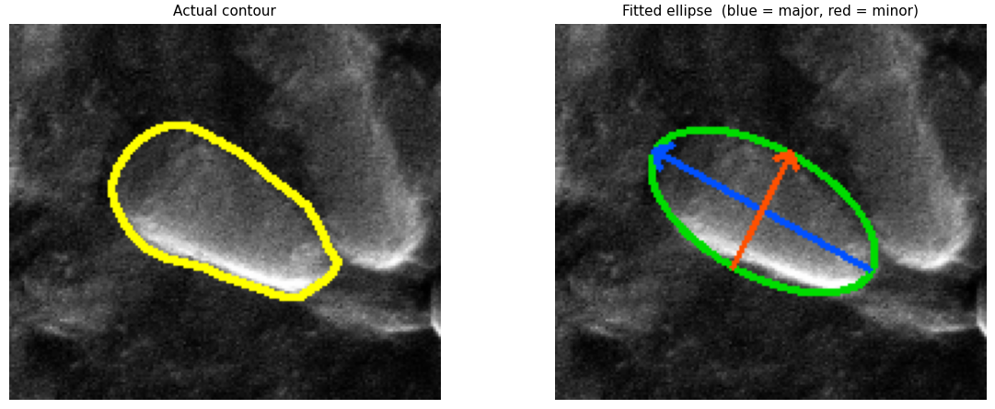
Figure 1. Bacterial morphology feature extraction for a representative bacterium. (left) Segmented bacterial contour (yellow) derived from Cellpose segmentation, overlaid on the original HR-SEM image. (right) Fitted ellipse (green) with major axis (blue, 1.321 µm) and minor axis (red, 0.677 µm) extracted using OpenCV. Projected area (2.81 µm²) was computed from the segmented region pixel count.

Surface Texture Analysis. Surface texture was quantified per bacterium as a proxy for membrane surface integrity. The grayscale image was normalized to the [0, 1] range, and bilateral filtering (15) was applied to smooth intensity variations while preserving spatially coherent surface structures. Each segmented cell was then eroded using a 5×5 kernel over two iterations to exclude boundary artifacts inherent to the segmentation process. A second-order polynomial surface (z = a + bx + cy + dx² + ey² + fxy) was fitted to the intensity values within the eroded region using least-squares regression, thereby removing the global intensity gradient and curvature effects. The residual surface was then computed, and cell texture was defined as the root-mean-square (RMS) of this residual (16). Higher RMS values indicate greater surface roughness, consistent with membrane disruption. A representative example of this pipeline, including the raw image, fitted surface, and residual texture map, is shown in Figure 2. Cells with fewer than 50 valid interior pixels after erosion were excluded to ensure a reliable polynomial fit.

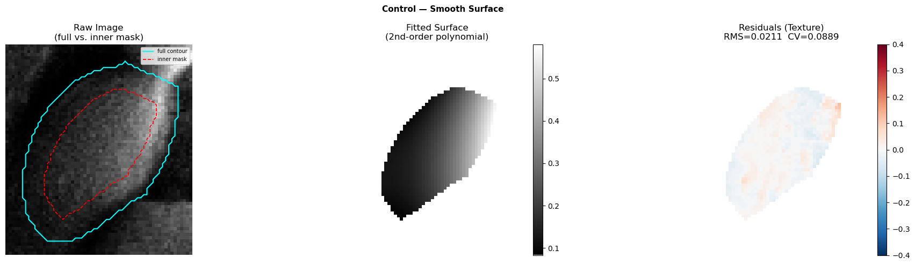
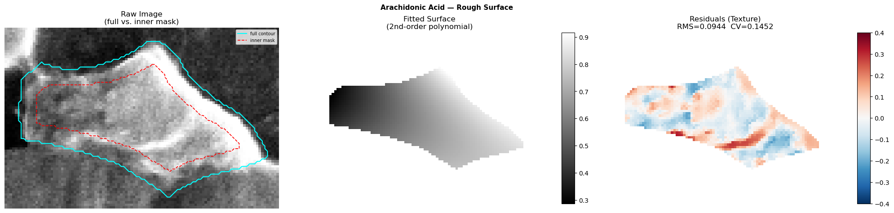

Figure 2. Texture analysis - (top row – control). (left) raw image patch of a representative S. mutans bacterium. (middle) polynomial surface fitted to the bacterium's intensity profile. (right) residuals (texture signal) after subtracting the fitted surface; low values (near zero, faint color) indicate a uniform bacteria surface, consistent with an intact bacterial envelope. (bottom row - 50 µg/ml AA) (left) raw image patch of a representative S. mutans bacterium. (middle) fitted polynomial surface. (right) residuals showing pronounced positiv e deviations (red), indicative of surface irregularity consistent with structural disruption of the bacterial envelope - in contrast to the near-zero residuals of the control bacterium.

Statistical Analysis for Cell Morphology. Cliff's delta (δ) was used as the primary effect-size measure for pairwise comparisons, as p-values become less informative at large sample sizes. Effect sizes were interpreted as: negligible (ns, |δ| < 0.147), small (*, |δ| ≥ 0.147), medium (**,|δ| ≥ 0.33), or large (***,|δ| ≥ 0.474) (17).

2.1.2 Biofilm Analysis
Background Removal. Images were divided into non-overlapping tiles of 10×10 px. For each tile, the standard deviation of pixel intensities was computed as a local variance score. Tiles with a variance score below five were considered candidate background, and adjacent candidate tiles were grouped into connected regions. A region was classified as true background only if it satisfied all of the following criteria:
- Minimum size: the region contained at least 50 tiles
- Low edge content: the region's mean variance score was below 0.1, ensuring that low-variance gaps within the biofilm matrix were not mistaken for empty substrate
- Sharp boundary: the surrounding contrast ratio was at least 20×, meaning the region was bordered by a sudden jump in intensity - as expected at the edge of empty substrate, but not within the biofilm matrix where neighboring tiles also carry low-to-moderate edge content
Regions meeting all criteria were masked out as background. The remaining area was retained as the biofilm mask. Biofilm-covered area (%) was defined as the fraction of total image area retained within the biofilm mask.
Biofilm Matrix Quantification. Morphological opening was applied to each image using a 3×3 kernel over two iterations to suppress noise. Images were then smoothed using a Fast Global Smoother edge-preserving filter (18). Edges were detected in the smoothed images using Sobel filtering (19) in both the x and y directions, and the two gradient maps were averaged to produce a single edge magnitude image. Small isolated edge components with area below 500 px² were removed as noise artifacts. Matrix complexity was then quantified by dividing the edge image into non-overlapping 100×100 px tiles; tiles where less than 30% of pixels fell within the biofilm mask were excluded to avoid border effects. Complexity per tile was defined as the standard deviation of edge intensities within the tile, and tile scores were averaged to produce a single image-level mean value per image, used in all subsequent comparisons. A representative example of the edge detection and tile-based complexity maps for both a control and AA-treated biofilm is shown in Figure 3.

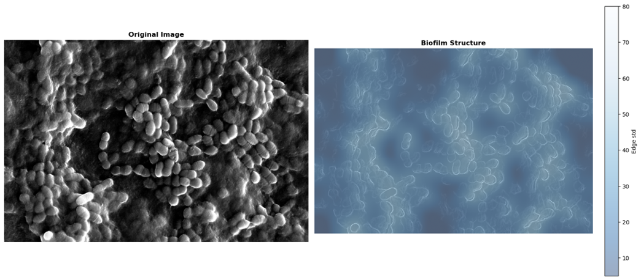
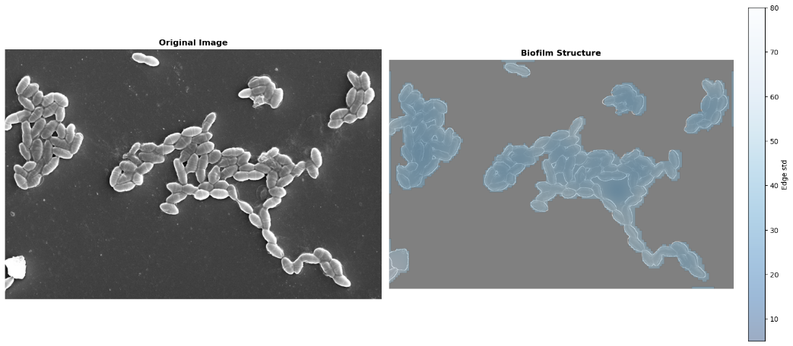
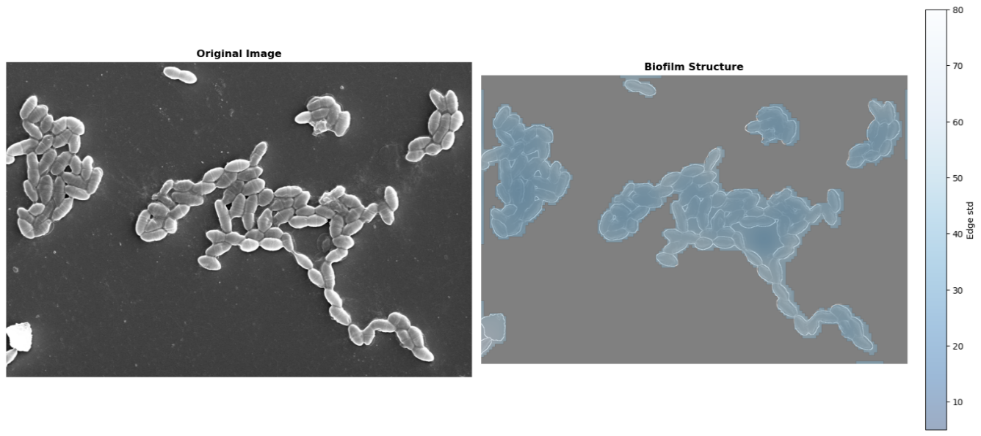
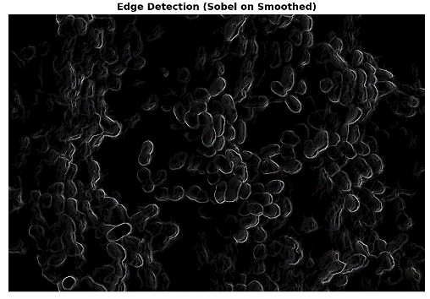
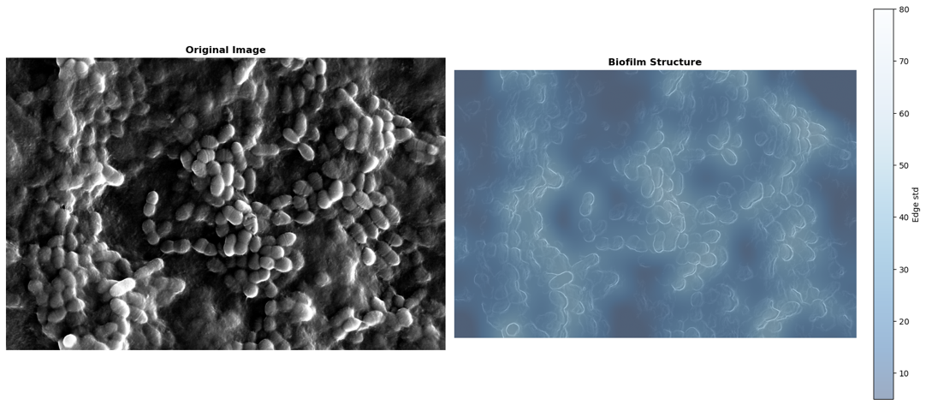
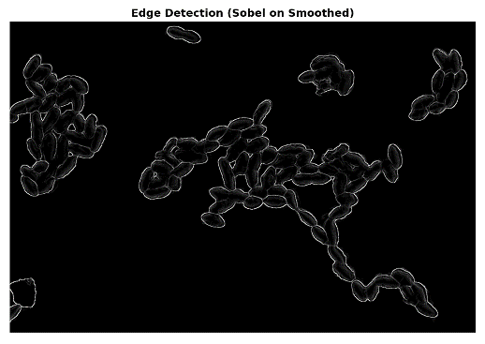
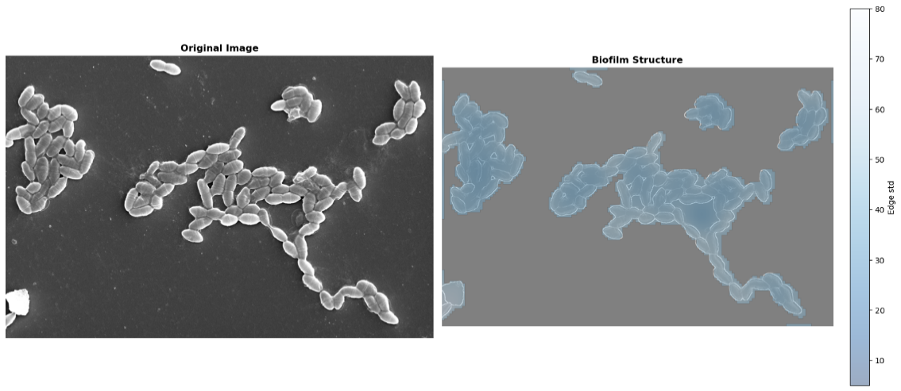

Figure 3. Representative SEM image and matrix quantification analysis - (top row - control). (left) original SEM image showing dense biofilm coverage with tightly packed bacterial cells embedded in an EPS matrix. (middle) Sobel edge detection map showing diffuse, low-contrast edge responses consistent with dense matrix obscuring individual cell boundaries. (right) tile-based texture heatmap of the same field, where color encodes local surface heterogeneity. The predominantly high-intensity (dark blue) tones indicate that most of the imaged area is matrix-dominated, with brighter blue regions corresponding to bacterial boundaries and structural transitions. (bottom row - 50 µg/ml AA) (left) original SEM image showing markedly reduced biofilm coverage, with bacteria appearing as dispersed clusters rather than a continuous mat. (middle) Sobel edge detection map showing bright, well-defined cell contours against a dark background, reflecting reduced matrix density and clearer structural definition. (right) tile-based texture heatmap of the same field, where color encodes local surface heterogeneity. Gray tiles indicate regions with no detectable bacterial or matrix signal. Within the remaining bacterial clusters, the shift toward lower-intensity (light blue) tones compared to the control indicates increased surface heterogeneity, consistent with reduced matrix density.

Statistical Analysis. Mean matrix complexity and biofilm coverage were each compared between the control group and each treatment group using the Mann–Whitney U test (20). Bonferroni correction was applied to account for the four simultaneous comparisons against the control group. Significance levels were assigned as: * p < 0.05, ** p < 0.01, *** p < 0.001.
2.2 Confocal Images Analysis
Confocal microscopy images of Streptococcus mutans biofilms were analyzed across five treatment conditions. The number of images per treatment group was as follows: control (n = 14), 6.25 µg/ml (n = 13), 12.5 µg/ml (n = 14), 25 µg/ml (n = 13), and 50 µg/ml (n = 15). All images were 1152x1152 pixels in X-Y dimension with 2.5 µm distance between subsequent layers in Z-plane and 1.35 µm/px in X-Y. 3D confocal volumes were adjusted to include layers that are symmetrical around the layer of maximal intensity, containing 90% of total sum of intensities. All figures relate to the adjusted volumes.

4. Results
4.1 SEM Single-cell Level Analysis
Figure 4.A represents Major axis length shows no significant change at low concentrations but increases significantly at higher concentrations: effect sizes (Cliff&#39;s delta, δ) are negligible and non-significant at 6.25 µg/ml (δ=−0.11, ns), negligible and non-significant at 12.5 µg/ml (δ=−0.07, ns), small and significant at 25 µg/ml (δ=−0.24, *↑), and small and significant at 50 µg/ml (δ=−0.24, *↑) .Minor axis length shows a concentration-dependent reversal - increasing at low concentrations and decreasing at higher concentrations relative to control: effect sizes (Cliff's delta, δ) are small and significant at 6.25 µg/ml (δ=−0.28, *↑), small and significant at 12.5 µg/ml (δ=−0.17, *↑), small and significant at 25 µg/ml (δ=+0.16, *↓), and small and significant at 50 µg/ml (δ=+0.27, *↓). Aspect ratio shows no significant change at low concentrations but increases significantly at higher concentrations, indicating cells become more elongated: effect sizes (Cliff's delta, δ) are negligible and non-significant at 6.25 µg/ml (δ=+0.10, ns), negligible and non-significant at 12.5 µg/ml (δ=+0.05, ns), small and significant at 25 µg/ml (δ=−0.34, **↑), and medium and significant at 50 µg/ml (δ=−0.39, **↑). (Fig 1)
Texture increases progressively with AA concentration: effect sizes (Cliff's delta, δ) are negligible and non-significant at 6.25 µg/ml (δ=−0.14, ns), small and significant at 12.5 µg/ml (δ=−0.15, *↑), large and significant at 25 µg/ml (δ=−0.60, ***↑), and medium and significant at 50 µg/ml (δ=−0.41, **↑).

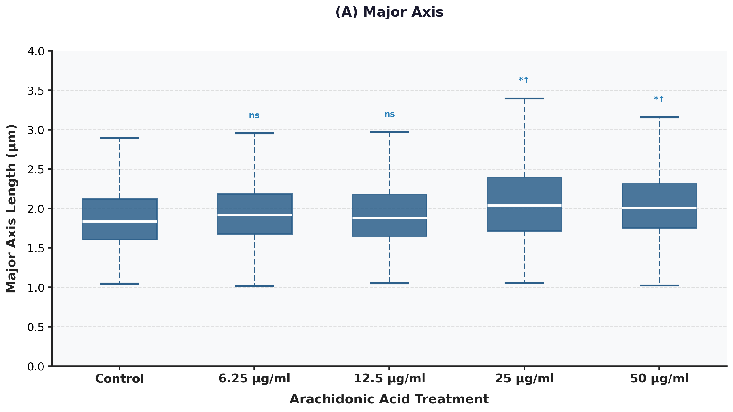
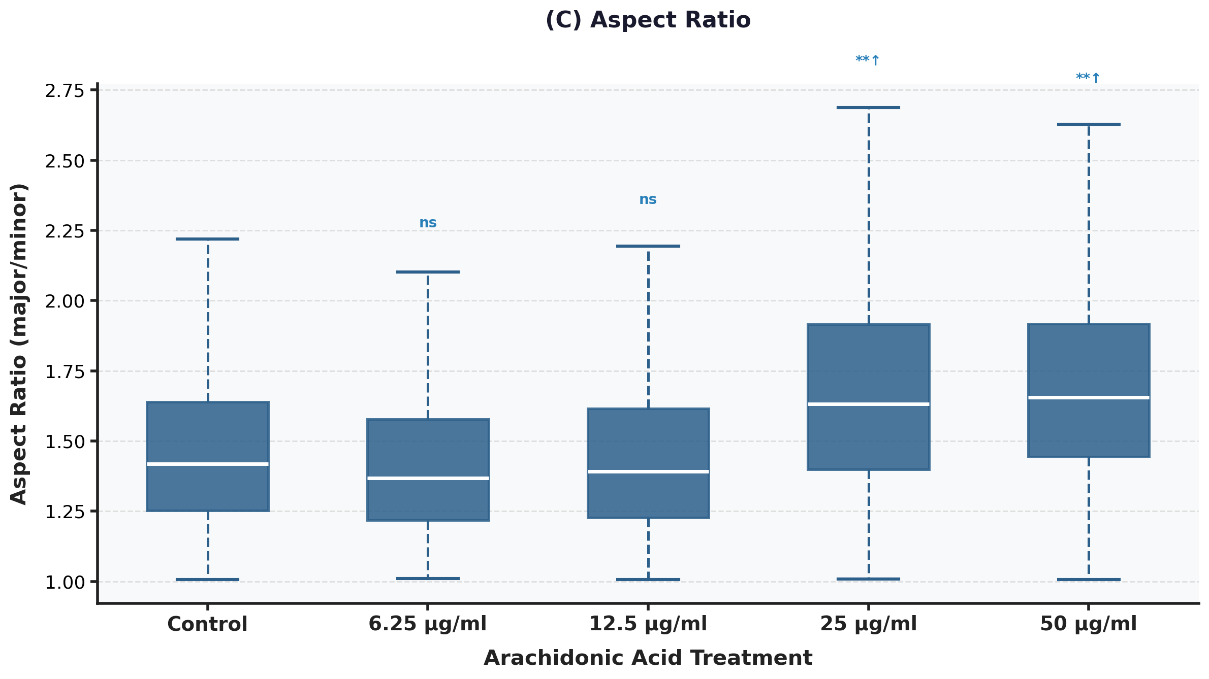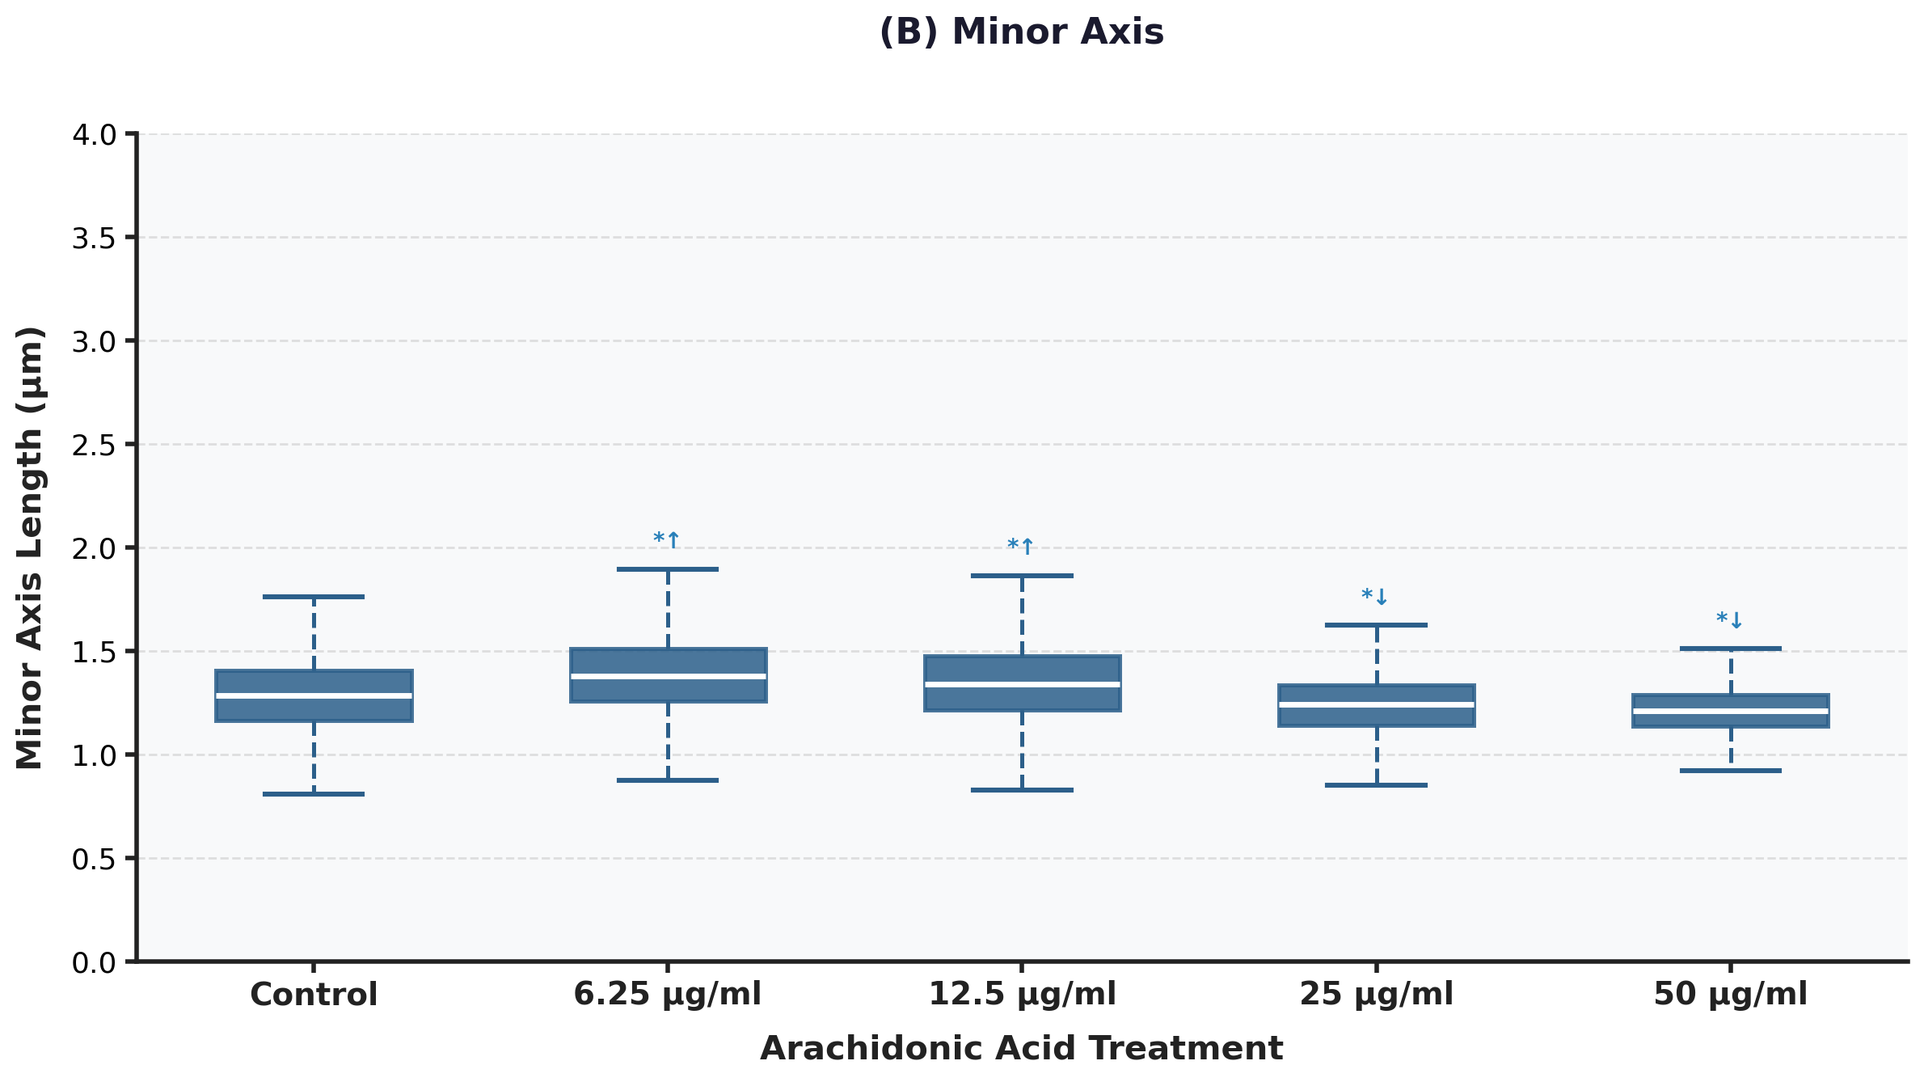
Figure 4. Cell shape analysis. (A) major axis length (µm). (B) minor axis length (µm). (C) aspect ratio of the elliptical approximation at the single cell level.
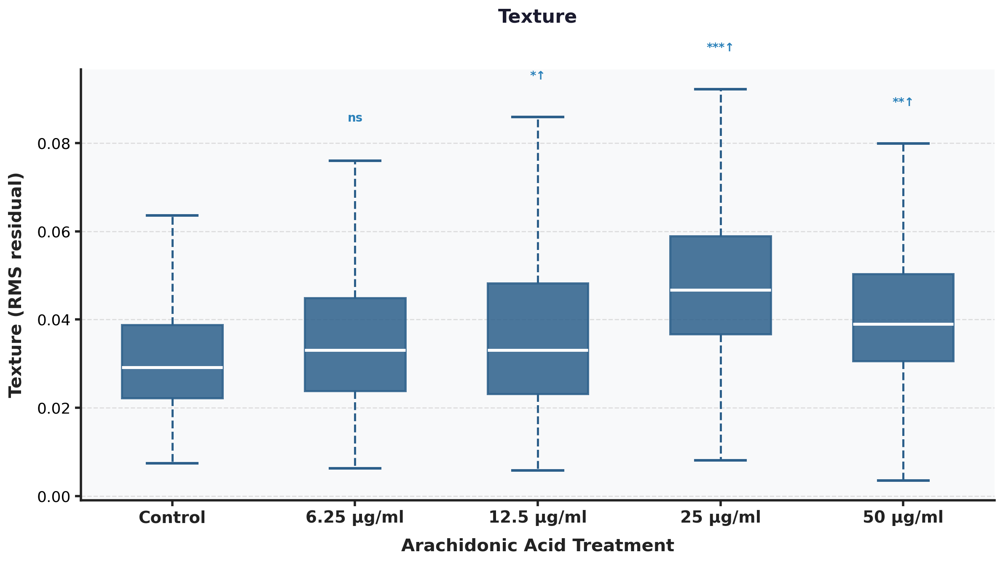
Figure 5. Bacterial surface texture.

4.2 SEM Whole Image Analysis
Coverage
Boxplots showing the percentage of image area occupied by bacteria At lower concentrations (≤12.5 µg/ml) coverage remains at ~100%, indistinguishable from control. A significant reduction in coverage is first observed at 25 µg/ml (p=2.45e-06, ***↓) and is further pronounced at 50 µg/ml (p=1.89e-07, ***↓), indicating biofilm disruption at higher concentrations. Comparisons by Mann-Whitney U test vs. control.
Matrix
Per image Statistically significant dose-dependent increases in matrix signal are observed at 12.5 µg/ml (p=0.002, **), 25 µg/ml (p=1.61e-06, ***), and 50 µg/ml (p=1.61e-06, ***) compared to control. Comparisons performed using Mann-Whitney U test vs. control; ↑ indicates direction of effect relative to control. ns = not significant.
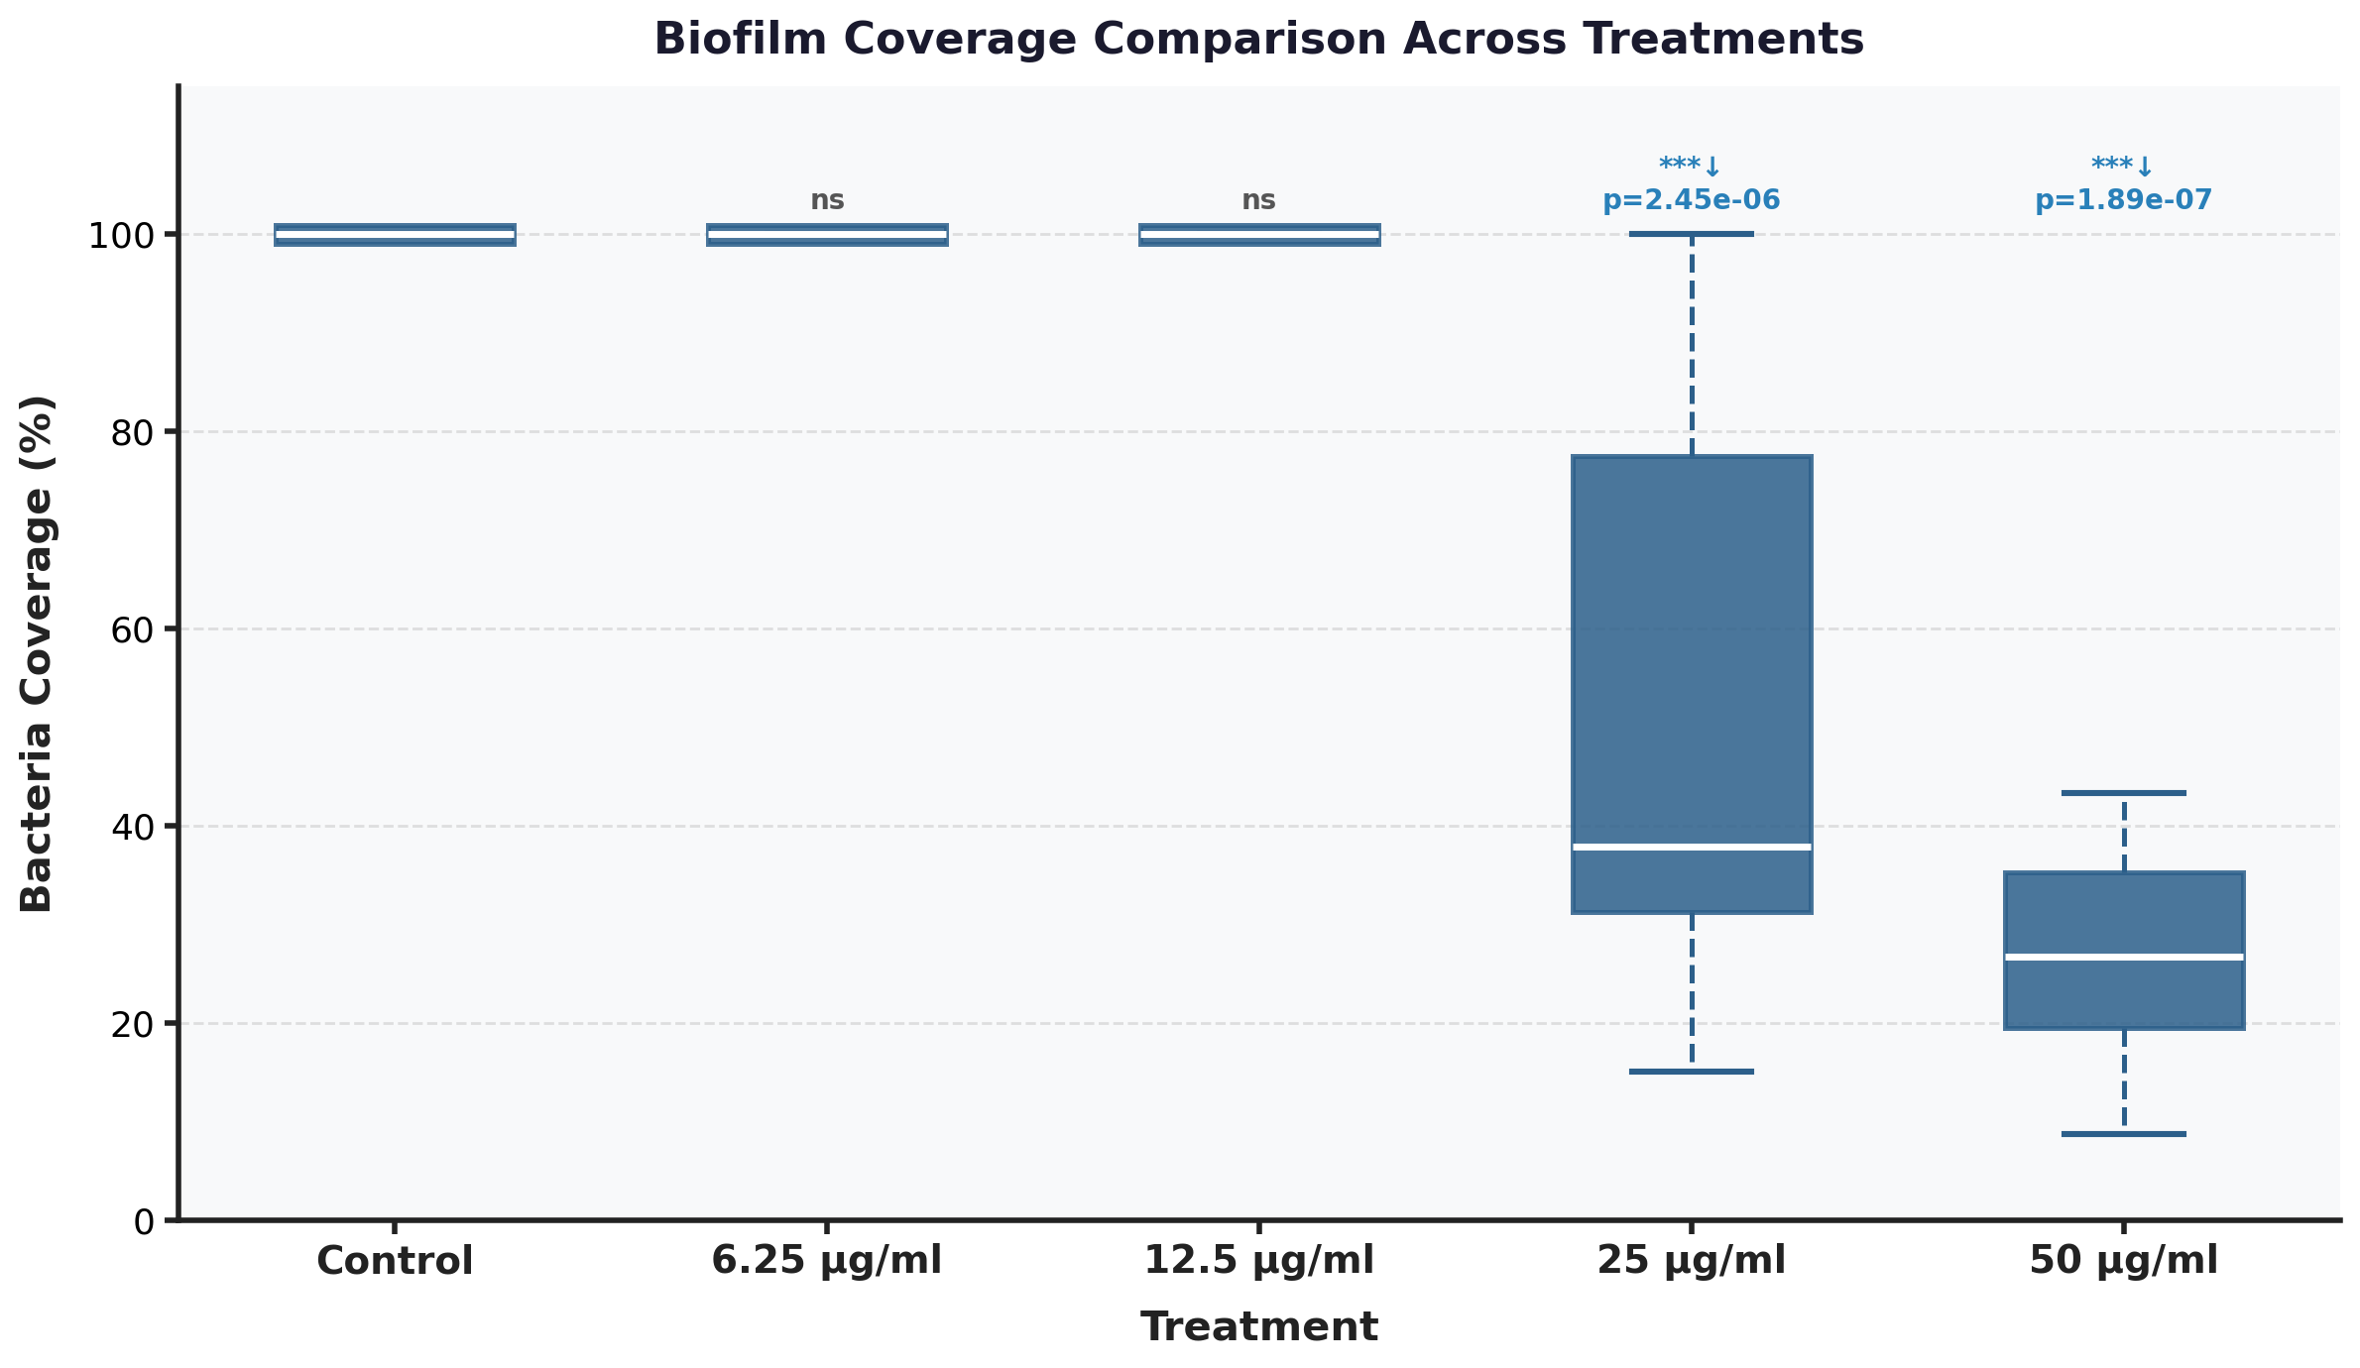
Figure 6. Biofilm coverage (%).
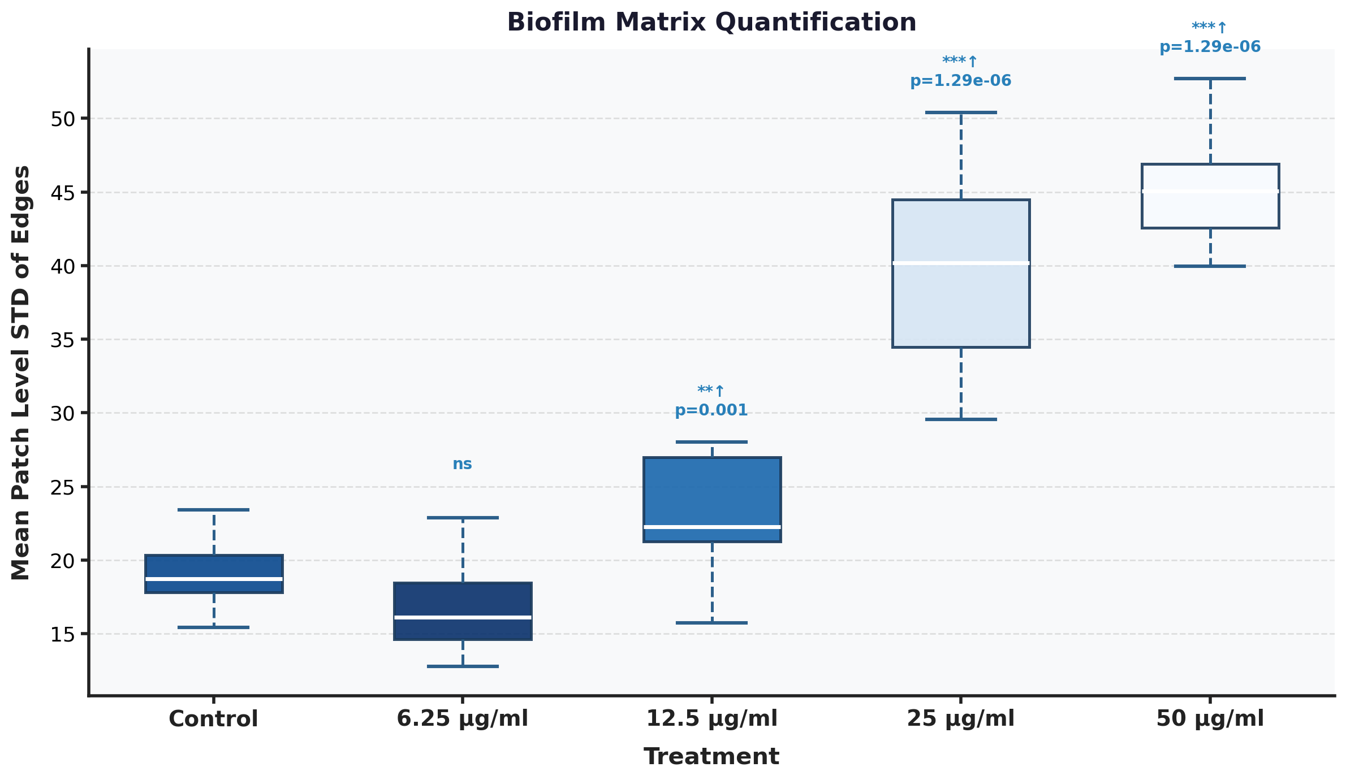
Figure 7. Biofilm Matrix Quantification. Lower values (darker colors) indicate higher levels of secreted matrix.

4.3 CLSM Analysis
 | Control | 6.25 μg/ml | 12.5 μg/ml | 25 μg/ml | 50 μg/ml
Central Intensity | 100% | 40% | 29% | 9% | 9%
Central Variance | 100% | 40% | 40% | 5% | 8%
Volume Intensity | 100% | 42% | 28% | 17% | 17%
Volume Variance | 100% | 37% | 29% | 4% | 6%
Porosity | 100% | 104% | 112% | 115% | 115%
Uniformity | 100% | 178% | 337% | 415% | 426%
Roughness | 100% | 142% | 91% | 96% | 81%
Laplacian Energy | 100% | 15% | 8% | 0% | 0%
Coefficient of Variation | 100% | 87% | 99% | 25% | 35%

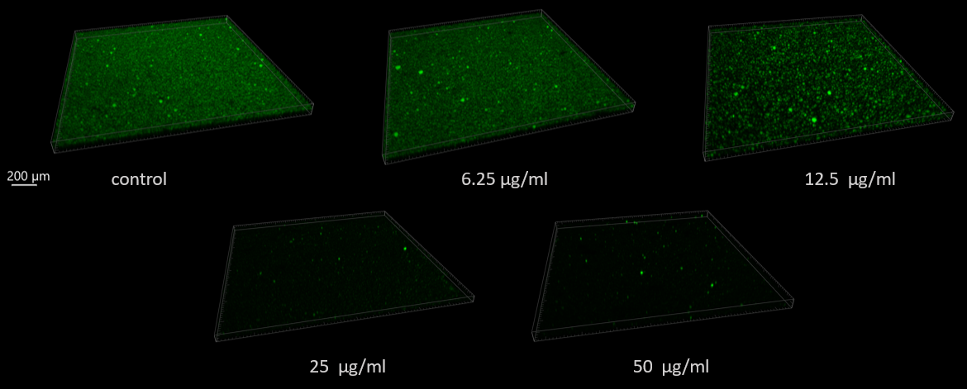
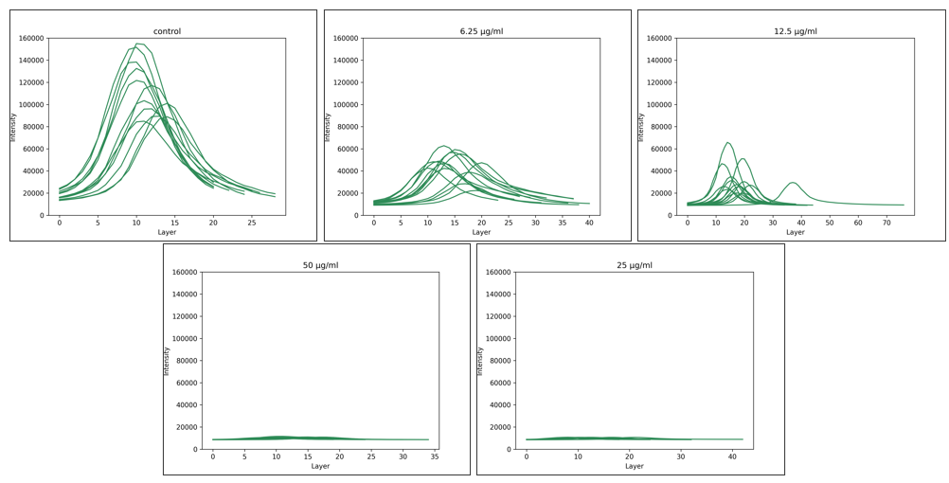
Figure 8. Raw layer data. (top) Representative confocal microscopy images of Streptococcus mutans biofilms. (bottom) Layer-wise sum intensities of the SYTO 9 signal. X-axis refers to the serial number of the layer, starting from the biofilm-surface interface.
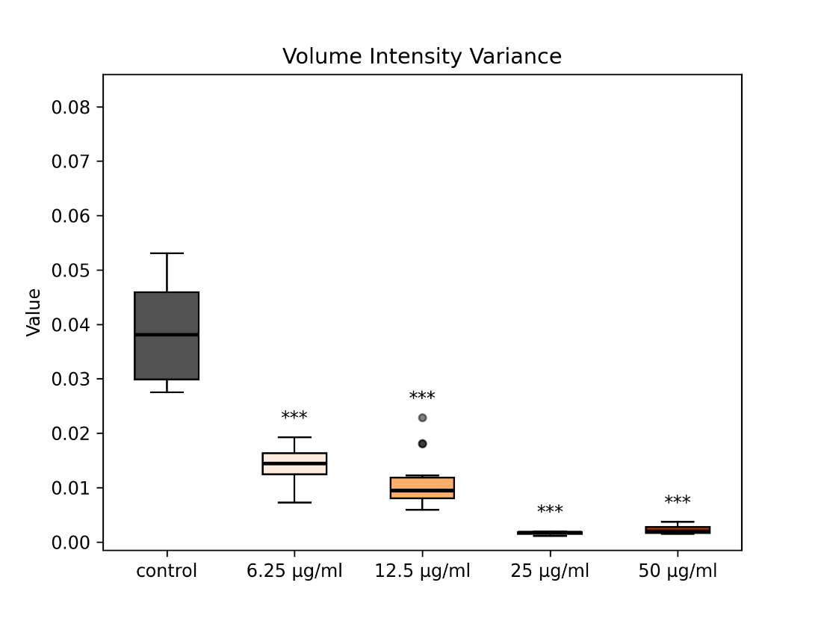
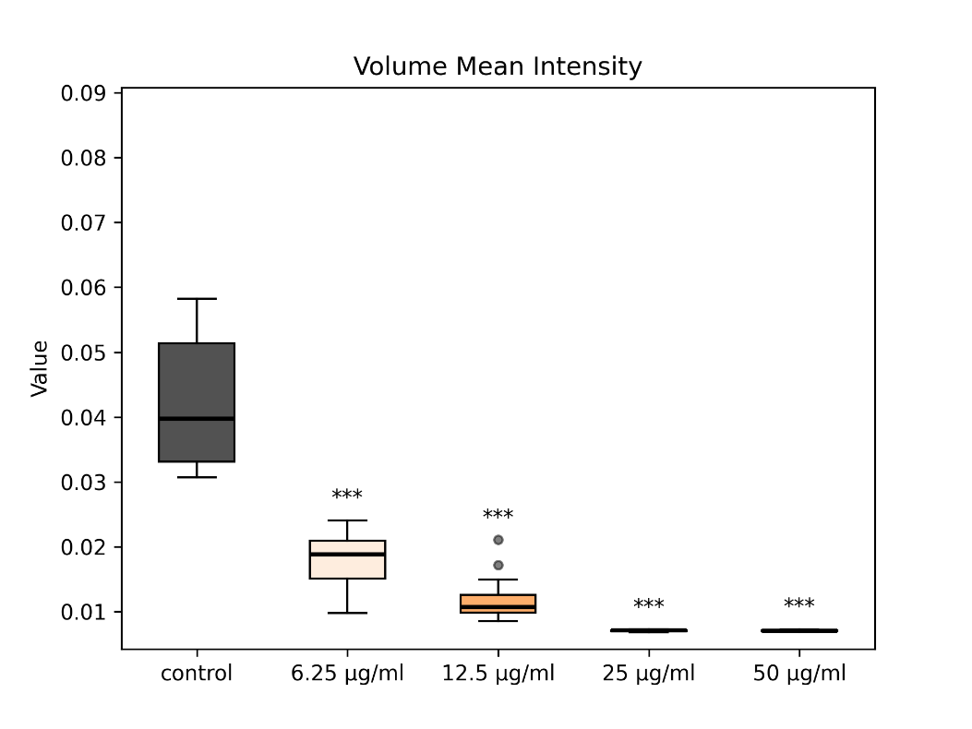
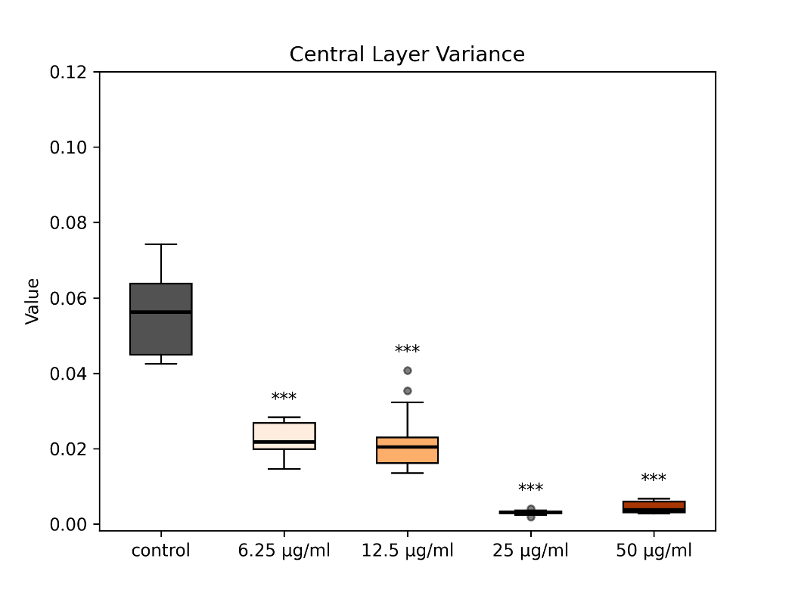
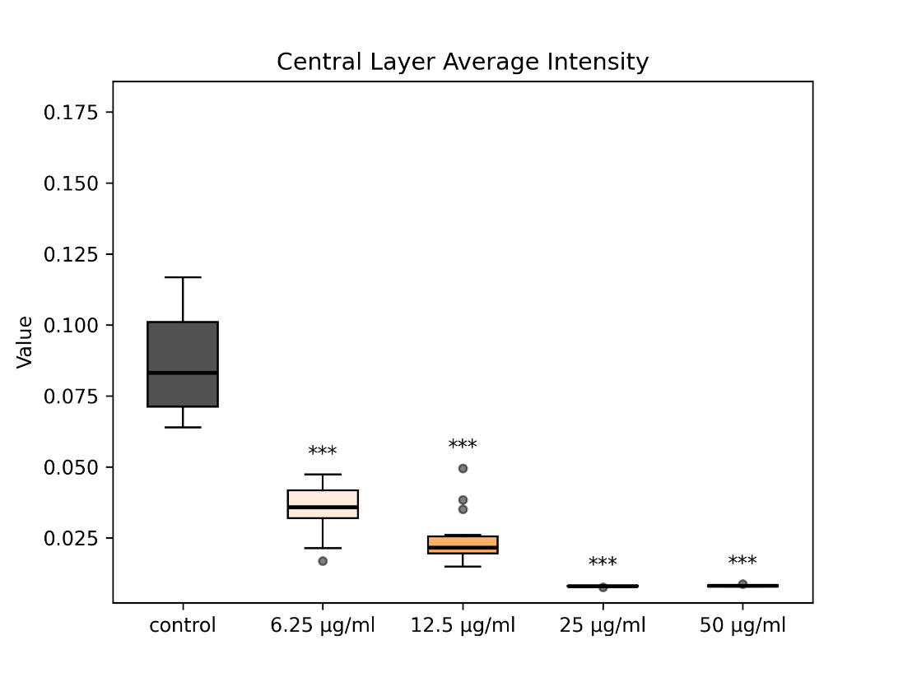
Figure 9. Biofilm SYTO9 intensity and variance. (Top row) Central layer is defined as the layer of maximal sum intensity – the figure above demonstrates the diminishing intensity and variance of GFP. (Bottom row) Mean intensity and variance of the whole volume shows marked reduction in GFP signal intensity and variance compared to control.
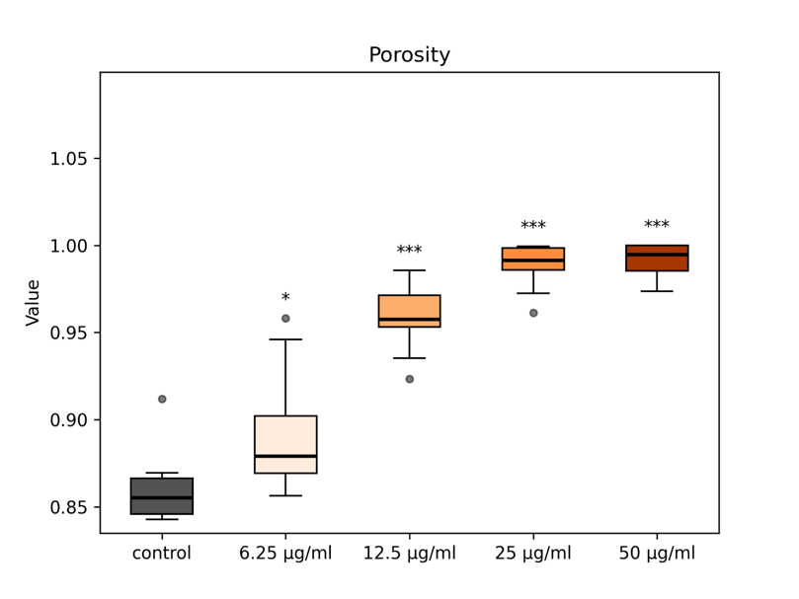
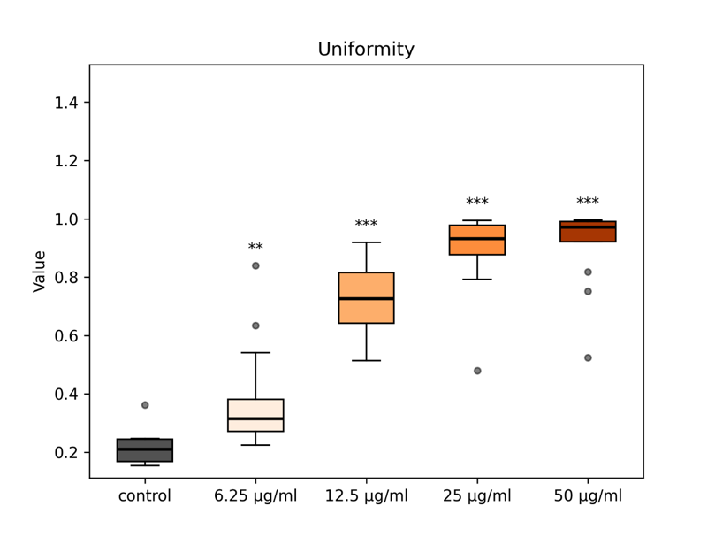
Figure 10. Biofilm Porosity and Uniformity. (left) Notable increase in porosity is observed with increasing amounts of AA. Porosity is calculated by using Otsu’s threshold to differentiate between pores and biofilm – porosity values represent the ratio of total pore pixels to the total number of pixels in the image. (right) Uniformity is calculated by computing the summation of intensity probabilities in the voxel histogram. For each intensity in the range [0,1], $p\left(i\right)=\frac{\#pixels with intensity i}{\#total pixels}$, uniformity is equal to $\sum_{i}{{p(i)}^{2}}$.

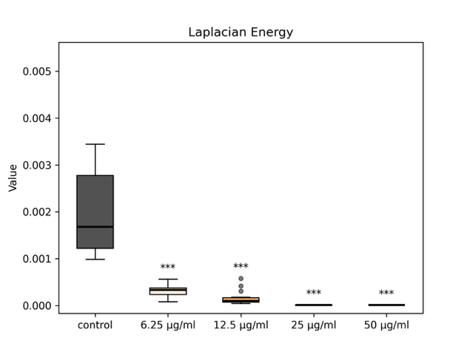
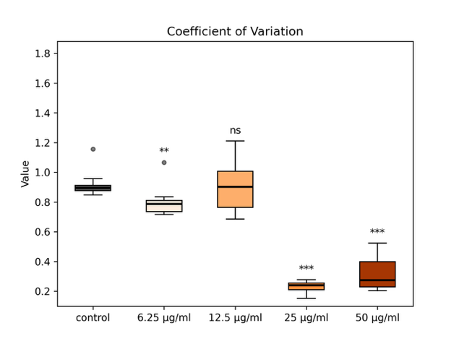
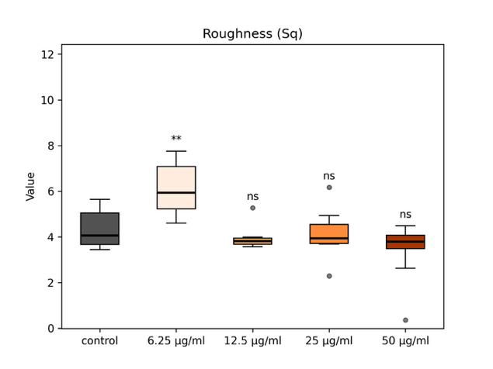
Figure 11. Roughness Laplacian Energy and Coefficient of Variation. (top) Roughness. Roughness was calculated by computing the surface height map, removal of global curvature by subtraction of best-fit plane and calculating the root mean square of the residual surface. $S_{q}=\sqrt{\frac{1}{N}\sum_{i=1}^{N}{{(I_{i}-I_{average})}^{2}}}$. (middle) Laplacian Energy. In order to assess fine-scale detail, average squared second derivative of intensities was computed. The figure above demonstrates that treated biofilms are characterized by smoother, slower varying structures of lower complexity. $\sum_{x,y,z}{{(∇^{2}I(x,y,z)}^{2}}$. (right) Coefficient of variation. Normalized variability (standard deviation) by mean intensity – highest concentrations demonstrate smoother signal relative to intensity magnitude - $\frac{σ_{pixels}}{μ_{pixels}}$. Uniformly weak staining is observed at the two higher AA concentrations, when compared to control and the two lower AA concentrations.

Disscusion
What did we introduced in this paper – SEM and confocal, cellular level and bioflm level.
Segnificant features we have found in th enalysis – just the interesting things.
Correlations between the different analysis: as the treatment dosage get higher – we can see in cell analysis that… and in biofilm that… and that is also inflected in the confocal analysis… Or contradicturies.
Future: labs need quontetive analysis, objective, standarize between all. Computer analysis and usage of seep learning…
Benefits of our analysis: Imaris – not open to everyone, BiofilmQ… what is our novalty – what did we added as an analysis that was not before.
Visualization is orevalent in microbiology – in every paper there are many visualizations and labs spend a lot of money on those imaging, so why not use them as quantative analysis.
Our paper: open source, cross modality, cross domain, software tool.

References
1. Sabino HAC, Valera FCP, Santos DV, Fantucci MZ, Titoneli CC, Martinez R, et al. Biofilm and Planktonic Antibiotic Resistance in Patients With Acute Exacerbation of Chronic Rhinosinusitis. Front Cell Infect Microbiol. 2022 Jan 17;11:813076. doi:10.3389/fcimb.2021.813076
2. Zhao A, Sun J, Liu Y. Understanding bacterial biofilms: From definition to treatment strategies. Frontiers in Cellular and Infection Microbiology. 2023;13:1137947. doi:10.3389/fcimb.2023.1137947
3. Jamal M, Ahmad W, Andleeb S, Jalil F, Imran M, Nawaz MA, et al. Bacterial biofilm and associated infections. Journal of the Chinese Medical Association. 2018 Jan;81(1):7–11. doi:10.1016/j.jcma.2017.07.012
4. Chamlagain M, Hu J, Sionov RV, Steinberg D. Anti-bacterial and anti-biofilm activities of arachidonic acid against the cariogenic bacterium Streptococcus mutans. Front Microbiol. 2024 Feb 26;15:1333274. doi:10.3389/fmicb.2024.1333274
5. Wilson C, Lukowicz R, Merchant S, Valquier-Flynn H, Caballero J, Sandoval J, et al. Quantitative and Qualitative Assessment Methods for Biofilm Growth: A Mini-review. Res Rev J Eng Technol. 2017 Dec;6(4):http://www.rroij.com/open-access/quantitative-and-qualitative-assessment-methods-for-biofilm-growth-a-minireview-.pdf. PubMed PMID: 30214915; PubMed Central PMCID: PMC6133255.
6. Heydorn A, Nielsen AT, Hentzer M, Sternberg C, Givskov M, Ersbøll BK, et al. Quantification of biofilm structures by the novel computer program comstat. Microbiology. 2000 Oct 1;146(10):2395–407. doi:10.1099/00221287-146-10-2395
7. Vorregaard M. Comstat2 — a modern 3D image analysis environment for biofilms [Master’s Thesis] [Internet]. [Lyngby, Denmark]: Technical University of Denmark; 2008. Available from: https://www2.compute.dtu.dk/pubdb/pubs/5628-full.html
8. Hartmann R, Jeckel H, Jelli E, Singh PK, Vaidya S, Bayer M, et al. Quantitative image analysis of microbial communities with BiofilmQ. Nat Microbiol. 2021 Jan 4;6(2):151–6. doi:10.1038/s41564-020-00817-4
9. Schneider CA, Rasband WS, Eliceiri KW. NIH Image to ImageJ: 25 years of image analysis. Nat Methods. 2012 Jul;9(7):671–5. doi:10.1038/nmeth.2089
10. Singh S, Muniz De Oliveira F, Wang C, Kumar M, Xuan Y, DeMazumder D, et al. SEMTWIST Quantification of Biofilm Infection in Human Chronic Wound Using Scanning Electron Microscopy and Machine Learning. Advances in Wound Care. 2025 Aug 1;14(8):393–408. doi:10.1089/wound.2024.0291
11. Ragi S, Rahman MH, Duckworth J, Jawaharraj K, Chundi P, Gadhamshetty V. Artificial Intelligence-Driven Image Analysis of Bacterial Cells and Biofilms. IEEE/ACM Trans Comput Biol and Bioinf. 2023 Jan 1;20(1):174–84. doi:10.1109/TCBB.2021.3138304
12. Stringer C, others. Cellpose: a generalist algorithm for cellular segmentation. Nature Methods. 2021;18:100–8. doi:10.1038/s41592-020-01018-x
13. Itseez. Open Source Computer Vision Library [Internet]. 2015. Available from: https://github.com/opencv/opencv
14. Van Der Walt S, Schönberger JL, Nunez-Iglesias J, Boulogne F, Warner JD, Yager N, et al. scikit-image: image processing in Python. PeerJ. 2014 Jun 19;2:e453. doi:10.7717/peerj.453
15. Tomasi C, Manduchi R. Bilateral filtering for gray and color images. In: Sixth International Conference on Computer Vision (IEEE Cat. No.98CH36271) [Internet]. Bombay, India: Narosa Publishing House; 1998 [cited 2026 Apr 10]. p. 839–46. Available from: http://ieeexplore.ieee.org/document/710815/ doi:10.1109/ICCV.1998.710815
16. Gadelmawla ES, Koura MM, Maksoud TMA, Elewa IM, Soliman HH. Roughness parameters. Journal of Materials Processing Technology. 2002;123:133–45. doi:10.1016/S0924-0136(02)00060-2
17. Romano J, Kromrey JD, Coraggio J, Skowronek J. Appropriate statistics for ordinal level data: Should we really be using t-test and Cohen’s d for evaluating group differences on the NSSE and other surveys. In: Proceedings of the Annual Meeting of the Florida Association of Institutional Research [Internet]. St. Petersburg, FL, USA; 2006. Available from: https://www.researchgate.net/publication/237544991
18. Farbman Z, Fattal R, Lischinski D, Szeliski R. Edge-preserving decompositions for multi-scale tone and detail manipulation. ACM Trans Graph. 2008 Aug;27(3):1–10. doi:10.1145/1360612.1360666
19. Irwin S, Gary F. A 3x3 isotropic gradient operator for image processing. In. 1968. Available from: https://www.researchgate.net/publication/285159837_A_33_isotropic_gradient_operator_for_image_processing
20. Mann HB, Whitney DR. On a Test of Whether one of Two Random Variables is Stochastically Larger than the Other. Ann Math Statist. 1947 Mar;18(1):50–60. doi:10.1214/aoms/1177730491

